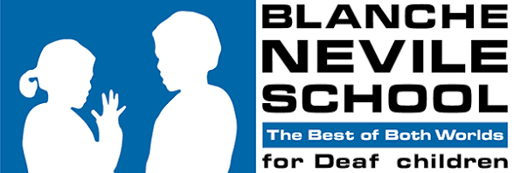
Dress Code
Belong, Thrive, Be PROUD
We do not have a school uniform. But we want everyone to come to school looking smart and ready to learn. Here is what that means.
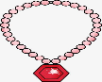 Jewellery
- Keep jewellery small and simple.
- Take all jewellery off for PE.
- Do not bring expensive jewellery or clothes to school. If it is lost or broken, we cannot pay you back.
 Clothes to wear
- Your top and bottoms must cover you from your shoulders to halfway down your legs. No gaps.
- Cover your stomach and your back.
- Cover your underwear – it should not show.
- Wear safe, comfortable shoes. You are on your feet all day.
 Clothes not to wear
- No bandanas or headscarves, unless it is for your religion.
- No see-through or ripped clothes.
- No pictures or words about alcohol, drugs, swearing, or gangs.
- No pictures or words that are unkind about someone's identity.
- No underwear showing.
- No flip-flops, sliders or bare feet.
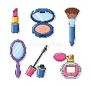 Make-up and nails
- If you wear make-up, keep it light / natural.
- No false eyelashes and no eyelash extensions.
- No coloured nail varnish.
- No acrylic nails, gel nails or nail extensions.
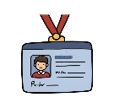Lanyard and ID badge (Secondary)
- Every secondary pupil gets a school lanyard and ID badge.
- Wear it around your neck, where people can see it, all day, every day.
This dress code is the same for everyone.
Summary
✓ Do | ✗ Don't
Cover shoulders to mid-leg, stomach and back | Crop tops, bare stomach or back
Wear safe, comfy shoes | Flip-flops, sliders or bare feet
Small, simple jewellery | Big or expensive jewellery
Light make-up, natural nails | False lashes, coloured varnish, acrylic/gel nails
Lanyard and ID badge around your neck (Secondary) | Lanyard left off or in a bag



